A

PROJECT REPORT ON

**SMART CAR PARKING SYSTEM USING IOT**

SUBMITTED BY

**NAME: EXAM NO.**

SHAIKH SAQLAIN SAJID

SHINDE NILIMA RAJARAM

SHINDE AMIT PANDURANG

Under the Guidance of

Mrs.S.V.Thuse



DEPARTMENT OF ELECTRONICS & TELECOMMUNICATION

P.E.S’S MODERN COLLEGE OF ENGINEERING

PUNE – 411 005.



SAVITRIBAI PHULE PUNE UNIVERSITY

2017 - 18

**CERTIFICATE**

This is to certify that

**NAME: EXAM NO.**

SHAIKH SAQLAIN SAJID

SHINDE NILIMA RAJARAM

SHINDE AMIT PANDURANG

of B.E. (E&TC) have successfully completed the project ‘**SMART CAR PARKING SYSTEM USING IOT’** during the academic during the academic year 2016-17.This report is submitted as partial fulfillment of the requirement of degree in E&TC Engineering as prescribed by University of Pune.

Prof Dr.K. Joshi Prof R.Kamathe Prof S.V.Thuse

**Principal H.O.D. Project Guide**

**P.E.S’s MCOE, Pune-5. E&TC**

**ACKNOWLEGMENT**

With the successful outcome of our project we take this opportunity to express our gratitude towards our internal guides Prof. S.V.Thuse who provided us with their valuable technical knowledge. There help was definitely not just technical but also gave us necessary motivation for the same. The various inputs suggested by them have helped us to gain knowledge and their suggestions have helped us to complete our project in stipulated time

We would like to acknowledge our ‘HEAD OF THE DEPARTMENT’,Prof.Kamathe for encouraging us and allowing us to do the project in college premises and providing us with all necessary equipment’s..

We would also like to thank the entire teaching and non-teaching staff for their co-operation which makes this project a reality.

**ABSTRACT**

Now days with the increase in vehicle production and world population, more and more spaces and facilities are required. In this project a new parking system called car parking system an android approach is proposed to assist driver to find vacant spaces in a parking in a shorter time. Different technologies are reviewed and compared to determine the best technology for developing this system.

This system uses IR sensors to detect the presence of vehicle in parking slot and display the vacant slot. We create the separate application on the smart phone and by using this application we find shorter and easier path to reach the destination with the help of Bluetooth module. Features of car parking system an android approach includes vacant parking space detection, display of vacant parking slots and give direction on smart phone application to move toward vacant parking slot.

This project also describes the use of a parking system in proper and efficient manner from the entrances into a parking area until the finding of a vacant parking slot. This prototype of car parking system an android approach will help car owners to improve their facilities inside car parking area to effectively guide car driver to vacant parking slot inside car parking area. This system is designed in two floors and each floor contains three parking slots and we can extend it as per our requirements. This system architecture defines the essential design features such as location of sensors, required number of sensors and LCD display board..

**TABLE OF CONTENT**

SR NO. CONTENT PAGE NO.

1. INTRODUCTION
2. LITERATURE SURVEY
3. SPECIFICATION
4. BLOCK DIAGRAM AND DESCRIPTIONS
5. HARDWARE DESIGN
6. PCB LAYOUT
7. SOFTWARE DESIGN
8. BILL OF MATERIALS
9. RESULT AND DISCUSSION
10. APPLICATION AND FUTURE MODIFICATIONS
11. CONCLUSION
12. REFERENCES
13. DATASHEETS

**INTRODUCTION**

We are going to use Infra-Red transmitters and receivers for each parking slot. The IR Receivers are connected to microcontroller. IR rays are obstructed when a car is parked in any parking slot. Thus PIC will come to know that which slot is empty and which slot is full.

We have chosen IR module instead of RF module because we want a receiver having line of sight communication with the transmitter. But RF does not require line of sight communication. And in case of LDR, there is scope for false triggering due to sunlight or headlight of car. So considering all these points we have finalized to use IR module.

For transmitter section we are going to use IR led’s. The system is fully controlled by microcontroller .An IR module is interfaced to microcontroller to recognize parking slot is empty or full. If the car enter in parking slot then there will be obstacle so that infrared rays are reflected due to obstacle and it will be incident on IR receiver and it will send signal to microcontroller accordingly microcontroller will turn on led and fare will start counting respectively.

Nowadays, smart car parking is one of the most adopted and fast growing smart city solutions across the world. The ability to connect, analyze and automate data gathered from devices, powered by and described as Internet of Things, is what makes smart car parking possible.

A parking solution can greatly benefit both the user and lot owner. Smart parking involves the use of low cost sensors, real-time data and applications that allow users to monitor available and unavailable parking spots

**LITERATURE SURVEY**

Now days in many multiplex systems there is a severe problem for car parking systems. There are many lanes for car parking, so to park a car one has to look for the all lanes. Moreover there is a lot of men labor involved for this process for which there is lot of investment. So the need is to develop a system which indicates directly which parking slot is vacant in any lane.

After doing survey in market we get the information about all these problems we come to the solution that we can developed the project which can reduce men labor and we can also achieve an efficient and advanced facilities for parking system

**SPECIFICATION**

**LCD DISPLY(16*2) :**

* 16 Characters x 2 Lines
* 5x7 Dot Matrix Character + Cursor
* HD44780 Equivalent LCD Controller/driver Built-In
* 4-bit or 8-bit MPU Interface
* Standard Type
* Works with almost any Microcontroller
* Great Value Pricing

**IR MODULE :**

* Peak wavelength λ p=940 nm
* 2.5 mm lead spacing
* Narrow beam angle (±10 degree)
* LM357 as a comparator

**GPS MODULE :**

* Simple UART interface.
* Ultra low power consumption =27mA 3.0V.

**GSM MODULE :**

* Integrated TCP / IP stack Features.
* Control via AT commands.
* Specifications for data GPRS class 10: max 85.6 kbps (downlink)

**BLOCK DIAGRAM AND DESCRIPTION**

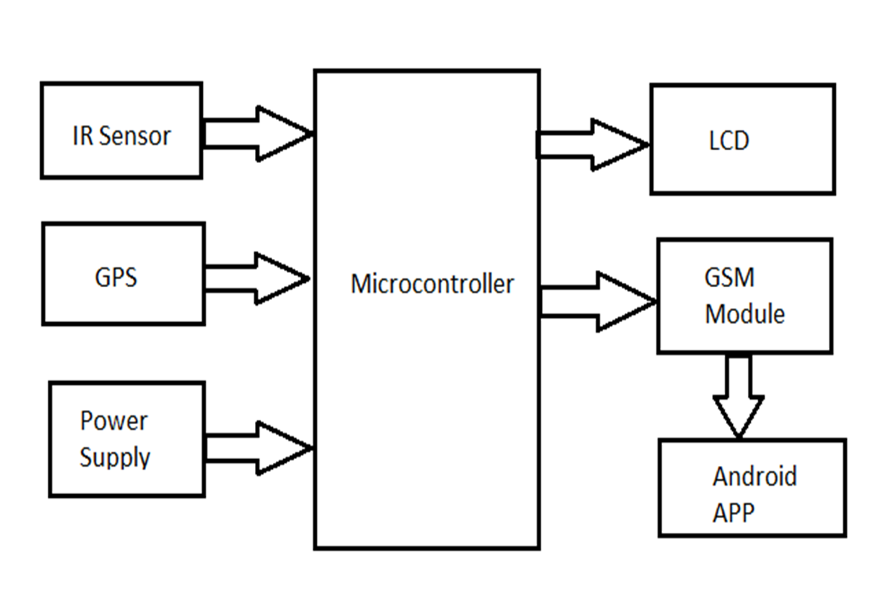

**POWER SUPPLY :**

Power supply is an electronic circuit that is designed to provide a constant dc voltage of predetermined value across load terminals irrespective of ac mains fluctuations or load variations.

In the circuit adapter is used which step down 230V AC mains voltage to 9V AC.Then this is given to a bridge rectifier to produce a full-wave rectified output. This is then given to a filter circuit to produce a dc voltage. The filter output may have some ac voltage variations and ripples. This is further filtered using a regulator IC 7805 whose output will be a constant 5V dc voltage.

**IR MODULE :**

An infrared sensor is an electronic device that emits in order to sense some aspects of the surroundings. An IR sensor can measure the heat of an object as well as detects the motion. These types of sensors measures only infrared radiation, rather than emitting it that is called as a passive IR sensor. Usually in the infrared spectrum, all the objects radiate some form of thermal radiations. These types of radiations are invisible to our eyes that can be detected by an infrared sensor. The emitter is simply an IR LED (Light Emitting Diode) and the detector is simply an IR photodiode which is sensitive to IR light of the same wavelength as that emitted by

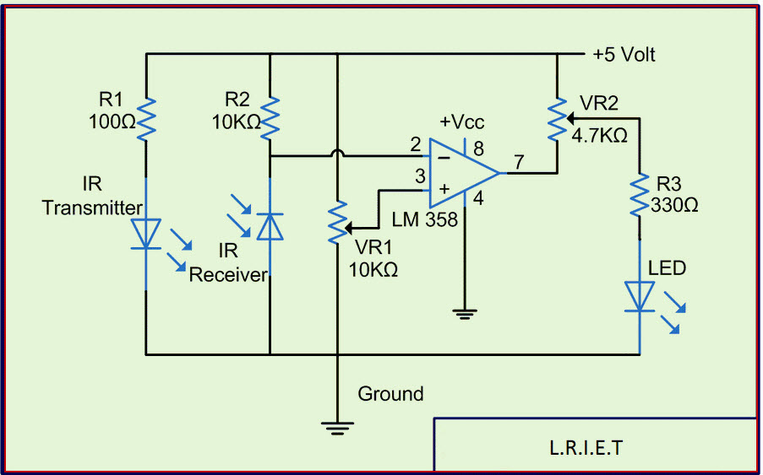

the IR LED. When IR light falls on the photodiode, The resistances and these output voltages, change in proportion to the magnitude of the IR light received.

**LCD DISPLAY:**   
 LCD (Liquid Crystal Display) screen is an electronic display module and find a wide range of applications. A 16×2 LCD display is very basic module and is very commonly used in various devices and circuits. These modules are preferred over seven segments and other multi segment LEDs. The reasons being: LCDs are economical; easily programmable; have no limitation of displaying special & even custom characters (unlike in seven segments), animations and so on.

The command register stores the command instructions given to the LCD. A command is an instruction given to LCD to do a predefined task like initializing it, clearing its screen, setting the cursor position, controlling display etc. The data register stores the data to be displayed on the LCD. The data is the ASCII value of the character to be displayed on the LCD. Click to learn more about internal structure of a LCD.

A 16×2 LCD means it can display 16 characters per line and there are 2 such lines. In this LCD each character is displayed in 5×7 pixel matrix. The LCD discussed in this section has 16 pins.

**HARDWARE DESIGN**

**SCHEMATIC DIAGRAM :**

**PCB LAYOUT :**

**SOFTWARE DESIGN**

**PROTEUS Simulation:**  
 Proteus 7.6 is a Virtual System Modelling (VSM) that combines circuit simulation, animated components and microprocessor models to co-simulate the complete microcontroller based designs.  
 This is the perfect tool for engineers to test their microcontroller designs before constructing a physical prototype in real time. This program allows users to interact with the design using on-screen indicators and/or LED and LCD displays and, if attached to the PC, switches and buttons.  
 One of the main components of Proteus 7.6 is the Circuit Simulation — a product that uses a SPICE3f5 analogue simulator kernel combined with an event-driven digital simulator that allow users to utilize any SPICE model by any manufacturer. Proteus VSM comes with extensive debugging features, including breakpoints, single stepping and variable display for a neat design prior to hardware prototyping.

**PROTEL PCB Design Software:**

For PCB designing we used PROTELsoftware. PROTEL is abbreviation of Procedure Oriented Type Enforcing Language. A number of PROTEL editions are offered. You can add an AutoRoute Module and/or a Schematic diagram Module to the Layout Editor.

**Algorithm:**

* Initially the vacant slot detection is made by controller.
* Transforming request for parking slot from the mobile using Android application.
* The parking allocation control unit gets the request slot number from the mobile.
* Checks for the parking slot for availability
* If it is free go to the next stage otherwise goes to the initial state.
* If the parking slot is free, the vacant slot and shortest path in the parking area is displayed on mobile phone.
* If the parking slot is not free then it will go to the initial stage.

**BILL OF MATERIALS**

|  |  |  |  |  |
| --- | --- | --- | --- | --- |
| **Sr no** | **Component** | **Specification** | **Quantity** | **Price** |
|  |  |  |  |  |
|  |  |  |  |  |
|  |  |  |  |
|  |  |  |  |
|  |  |  |  |
|  |  |  |  |  |
|  |  |  |  |  |
|  |  |  |  |  |
|  |  |  |  |  |
|  |  |  |  |  |
|  |  |  |
|  |  |  |
|  |  |  |  |  |
|  |  |  |
|  |  |  |  |  |
|  |  |  |  |  |
|  |  |  |  |  |
|  |  |  |  |  |
|  | | | |  |

**RESULTS AND DISCUSSIONS**

In this way we conclude that this project displays the vacant car parking slots using microcontroller and android cell phone. The proposed parking management system takes into account all possible attributes that is expected from it.

The most significant parking problem that is finding vacant space & smallest path to reach that vacant space. It helps to give the proper management of parking.

**APPLICATION & FUTURE MODIFICATION**

* **Application :**

This system can be used in different parking area like

* Building
* City center malls
* Colleges
* Companies
* Airport
* Railway station

**Future modification :**

* This can be expanded in the sense of security. Using metal detectors and CCTV cameras security of the parking area can be enhanced.
* We can add pick and place facility to park the cars automatically.
* We can enhance this project by using image processing.

**CONCLUSIONS**

The project titled ‘SMART CAR PARKING SYSTEM USING IOT’ gave the following conclusions:-

In this way we conclude that this project displays the vacant car parking slots using microcontroller and android cell phone. The proposed parking management system takes into account all possible attributes that is expected from it.

The most significant parking problem that is finding vacant space & smallest path to reach that vacant space. It helps to give the proper management of parking.

**REFERENCES**

* Jae Kyu Suhr and Ho Gi Jung, “Sensor Fusion Based Vacant Parking Slot Detection and Tracking” IEEE transactions on intelligent transportation systems, vol. 15, no. 1, Jae Kyu Suhr and Ho Gi Jung, “Sensor Fusion-Based Vacant Parking Slot Detection and Tracking” IEEE transactions on intelligent transportation systems, vol. 15, no. 1, pp. 21-36, February 2014.
* Jae Kyu Suhr and Ho Gi Jung, “Fully-automatic Recognition of Various Parking Slot Markings in Around View Monitor (AVM) Image Sequences” 2012 15th International IEEE Conference on Intelligent Transportation Systems Anchorage, Alaska, USA, pp. 129-1299,September 16-19, 2012
* www.electronicsforu.com
* http://plasmacomp.com/blogs/benefits-of-smart-parking-solution
* International Journal of Innovative Research in Computer and Communication Engineering (An ISO 3297: 2007 Certified Organization) Vol. 4, Issue 3, March 2016 “Car Parking System an Android App”